Blossom Watch 2021

Alan Millington

2021-03-22 14:27:25

|  |  |
| --- | --- |
| hashtag | count |
| blossom | 2326 |
| blossomwatch | 1484 |
| NationalTrust + BlossomWatch | 36 |
| EveryoneNeedsNature | 251 |
| None | 1811 |

# Timeline

## Tweets by day

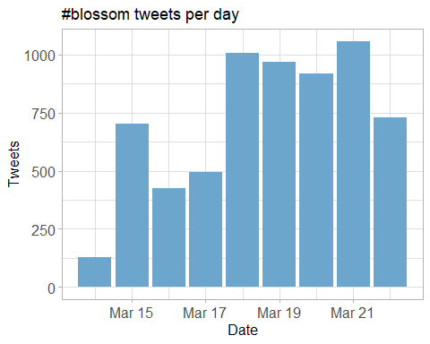

## Tweets by day and time

Filtered for dates March, London time. 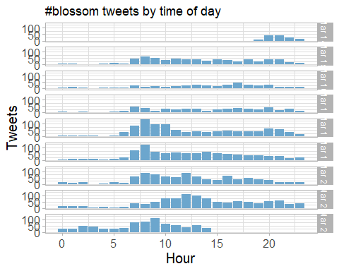

# Users

## Top tweeters

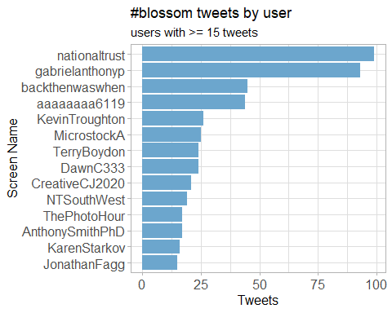

## Sources

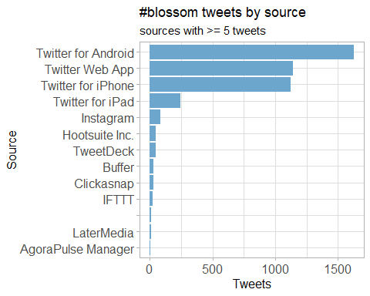

# Networks

## Replies

The “replies network”, composed from users who reply directly to one another.

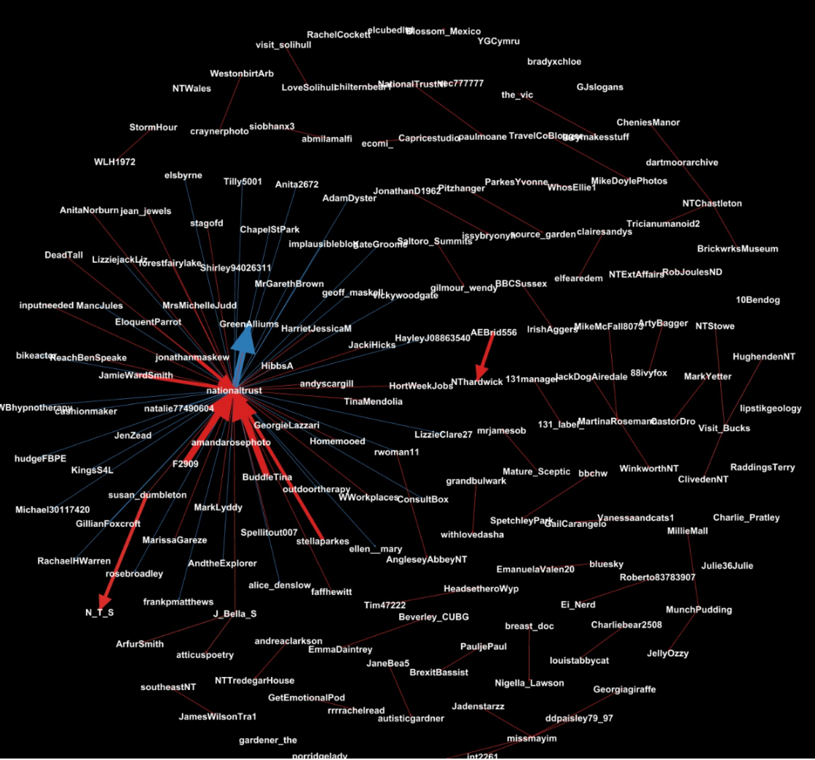

## Mentions

The “mentions network”, where users mention other users in their tweets.



# Retweets

## Retweet proportion

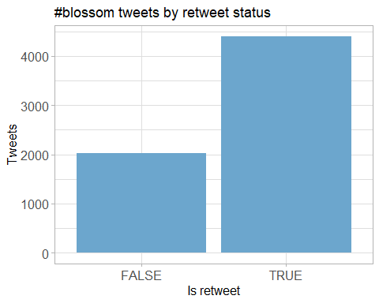

## Retweet count

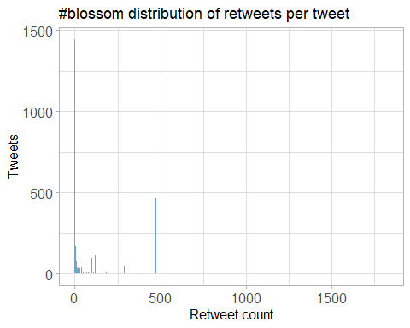

## Top retweets

|  |  |  |
| --- | --- | --- |
| screen_name | text | retweet_count |
| nationaltrust | Pause to soak up the sweet scents and soft songs emanating from blossom branches. These colourful trees are a feast for the senses. #BlossomWatch <https://t.co/GsXfF5KPAE> | 236 |
| DrDarrenRFlower | Central Park New York #spring #spring2021 #blossom #cherry <https://t.co/Oimq2hRU1k> | 139 |
| nationaltrust | Everywhere these delicate flowers emerge, they bring delight with them. Thanks to everyone who’s helped spread the joys of blossom so far - keep the photos coming with #BlossomWatch. Photos: Joanna A, Catherine A, Shonali B, Cara W. <https://t.co/6znNDEdvKC> | 121 |
| nationaltrust | Spring is on the way. Celebrate the arrival of blossom near you with #BlossomWatch: <https://t.co/TaQxr1YkU8> <https://t.co/kQ93UDZlCP> | 120 |
| nationaltrust | If you’re lucky enough to spot a hare hopping around, the feeling of elation will stick with you all day. #EveryoneNeedsNature <https://t.co/Vpo5aADU9Q> | 100 |
| nationaltrust | <U+0001F338>#BlossomWatch<U+0001F338> Lockdowns have changed the nation’s relationship with nature for the better. We are feeling more connected thanks to our daily strolls and taking more notice of the changing seasons. <https://t.co/JtIkqgUorV> | 92 |
| nationaltrust | Happily dancing in the breeze, a golden daffodil is full of cheer. #EveryoneNeedsNature <https://t.co/hSOWdCCnPL> | 87 |
| nationaltrust | One of life’s simple pleasures that can be enjoyed from anywhere. Engross yourself in the calming colours of a sunrise. #EveryoneNeedsNature <https://t.co/l5xkDICUPn> | 68 |
| ampomata | This is my new painting “Bed Of Roses”. You can check it out here: <https://t.co/GoYnqeM1YY> #art #arte #oleo #kunst #oilpainting #contemporaryart #ArtistOnTwitter #blossom #flower #floral #spring #pink #red #roses #field #artprints #flowers #garden <https://t.co/7y9skbUaMs> | 67 |
| MikeDoylePhotos | Spring colour at Sheffield Park, East Sussex. #Sussex #England #NationalTrust #landscape #landscapephotography #travel #travelphotography #photo #photography #photooftheday #NaturePhotography <https://t.co/uFdcfnor39> | 60 |
| MikeDoylePhotos | Early autumn at Sheffield Park, East Sussex. #Sussex #England #NationalTrust #landscape #landscapephotography #travel #travelphotography #photo #photography #photooftheday #NaturePhotography <https://t.co/fqSC6f0xMQ> | 58 |
| nationaltrust | <U+0001F338> With buds beginning to burst weâ€™re asking you to help us track the blossom as it appears. Just add #BlossomWatch to your tweets, with location settings on, to add your sightings to our map: <https://t.co/Oto3d8C9ZQ> <https://t.co/9a3Q2umF03> | 54 |
| nationaltrust | This spring, spend time under the delicate blooms of a blossom tree and watch as nature’s confetti dances to the ground. Share your pictures of pink, white and green with us using #BlossomWatch<U+0001F338> <https://t.co/0WFkQ61nfD> | 52 |
| nationaltrust | A bright burst of yellow Forsythia is like the sunshine after the rain. Flowering with the spring bulbs, these blooms are a sure sign of the gardens we care for reawakening after winter. #EveryoneNeedsNature <https://t.co/eRc7pCw2nJ> | 46 |
| nationaltrust | As the days lengthen, take an early evening walk and listen out for the blackbird chorus. Perched as high as they can, they fill the spring air with song. #EveryoneNeedsNature <https://t.co/fokl4eudbL> | 43 |
| MikeDoylePhotos | A view of the Middle Lake at Sheffield Park, East Sussex. #Sussex #England #NationalTrust #landscape #landscapephotography #travel #travelphotography #photo #photography #photooftheday #NaturePhotography <https://t.co/HAeeTUTOI4> | 41 |
| dadajay001 | Saw it.. Liked it.. So clicked it..<U+2764><U+FE0F> #Foryou #Blossom <U+0001F60D> #My_click <https://t.co/Io57jIGBjB> | 40 |
| pac1610 | Beautiful #BlossomWatch and a touch of blue sky on my local walk! <U+0001F338><U+0001F33F><U+0001F497><U+0001F33F><U+0001F338>@ThePhotoHour @StormHour @StormHourMark @LensAreLive @lebalzin #ePHOTOzine #WorcestershireHour #spring #TwitterNatureCommunity <https://t.co/ylDerLzUwu> | 37 |
| nationaltrust | Nature’s alarm clock is getting louder with each new day as the birds look to find their spring mates. Which birds are waking you up in the morning? Photos: Jenni B, @NTCastleWard #EveryoneNeedsNature <https://t.co/qFLlRf3gL7> | 36 |
| MikeDoylePhotos | A summertime view of the house at Sheffield Park, East Sussex. #Sussex #England #NationalTrust #landscape #landscapephotography #travel #travelphotography #photo #photography #photooftheday #NaturePhotography #architecturephotography <https://t.co/RKDuxeqWpw> | 34 |

# Favourites

## Favourite proportion

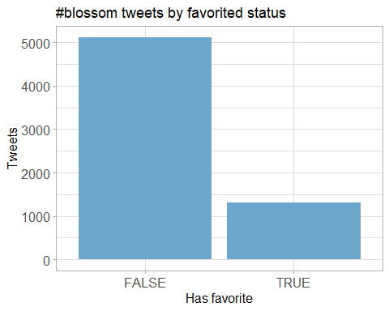

## Favourite count

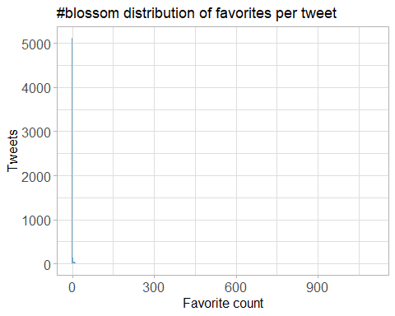

## Top favourites

|  |  |  |
| --- | --- | --- |
| screen_name | text | favorite_count |
| nationaltrust | Pause to soak up the sweet scents and soft songs emanating from blossom branches. These colourful trees are a feast for the senses. #BlossomWatch <https://t.co/GsXfF5KPAE> | 1104 |
| DrDarrenRFlower | Central Park New York #spring #spring2021 #blossom #cherry <https://t.co/Oimq2hRU1k> | 762 |
| nationaltrust | If you’re lucky enough to spot a hare hopping around, the feeling of elation will stick with you all day. #EveryoneNeedsNature <https://t.co/Vpo5aADU9Q> | 697 |
| nationaltrust | Everywhere these delicate flowers emerge, they bring delight with them. Thanks to everyone who’s helped spread the joys of blossom so far - keep the photos coming with #BlossomWatch. Photos: Joanna A, Catherine A, Shonali B, Cara W. <https://t.co/6znNDEdvKC> | 691 |
| nationaltrust | <U+0001F338>#BlossomWatch<U+0001F338> Lockdowns have changed the nation’s relationship with nature for the better. We are feeling more connected thanks to our daily strolls and taking more notice of the changing seasons. <https://t.co/JtIkqgUorV> | 562 |
| nationaltrust | Spring is on the way. Celebrate the arrival of blossom near you with #BlossomWatch: <https://t.co/TaQxr1YkU8> <https://t.co/kQ93UDZlCP> | 499 |
| nationaltrust | Happily dancing in the breeze, a golden daffodil is full of cheer. #EveryoneNeedsNature <https://t.co/hSOWdCCnPL> | 484 |
| MikeDoylePhotos | Early autumn at Sheffield Park, East Sussex. #Sussex #England #NationalTrust #landscape #landscapephotography #travel #travelphotography #photo #photography #photooftheday #NaturePhotography <https://t.co/fqSC6f0xMQ> | 465 |
| MikeDoylePhotos | Spring colour at Sheffield Park, East Sussex. #Sussex #England #NationalTrust #landscape #landscapephotography #travel #travelphotography #photo #photography #photooftheday #NaturePhotography <https://t.co/uFdcfnor39> | 431 |
| nationaltrust | Nature’s alarm clock is getting louder with each new day as the birds look to find their spring mates. Which birds are waking you up in the morning? Photos: Jenni B, @NTCastleWard #EveryoneNeedsNature <https://t.co/qFLlRf3gL7> | 416 |
| nationaltrust | One of life’s simple pleasures that can be enjoyed from anywhere. Engross yourself in the calming colours of a sunrise. #EveryoneNeedsNature <https://t.co/l5xkDICUPn> | 407 |
| MikeDoylePhotos | A view of the Middle Lake at Sheffield Park, East Sussex. #Sussex #England #NationalTrust #landscape #landscapephotography #travel #travelphotography #photo #photography #photooftheday #NaturePhotography <https://t.co/HAeeTUTOI4> | 394 |
| nationaltrust | As the days lengthen, take an early evening walk and listen out for the blackbird chorus. Perched as high as they can, they fill the spring air with song. #EveryoneNeedsNature <https://t.co/fokl4eudbL> | 376 |
| nationaltrust | A bright burst of yellow Forsythia is like the sunshine after the rain. Flowering with the spring bulbs, these blooms are a sure sign of the gardens we care for reawakening after winter. #EveryoneNeedsNature <https://t.co/eRc7pCw2nJ> | 361 |
| nationaltrust | This spring, spend time under the delicate blooms of a blossom tree and watch as nature’s confetti dances to the ground. Share your pictures of pink, white and green with us using #BlossomWatch<U+0001F338> <https://t.co/0WFkQ61nfD> | 317 |
| MikeDoylePhotos | Some more spring colour at Sheffield Park, East Sussex. #Sussex #England #NationalTrust #landscape #landscapephotography #travel #travelphotography #photo #photography #photooftheday #NaturePhotography <https://t.co/N5aG6i4wW5> | 311 |
| MikeDoylePhotos | A summertime view of the house at Sheffield Park, East Sussex. #Sussex #England #NationalTrust #landscape #landscapephotography #travel #travelphotography #photo #photography #photooftheday #NaturePhotography #architecturephotography <https://t.co/RKDuxeqWpw> | 288 |
| nationaltrust | <U+0001F338> With buds beginning to burst weâ€™re asking you to help us track the blossom as it appears. Just add #BlossomWatch to your tweets, with location settings on, to add your sightings to our map: <https://t.co/Oto3d8C9ZQ> <https://t.co/9a3Q2umF03> | 239 |
| MikeDoylePhotos | Autumnal view at Sheffield Park, East Sussex. #Sussex #England #NationalTrust #landscape #landscapephotography #travel #travelphotography #photo #photography #photooftheday #NaturePhotography <https://t.co/FqII3JWs8w> | 237 |
| nationaltrust | When you feel the warmth of the spring sun, keep an eye out for the fluttering of pale wings. Brimstone butterflies are a welcome sign of the changing season. #EveryoneNeedsNature <https://t.co/MCfhLeds7k> | 215 |

# Quotes

## Quote proportion

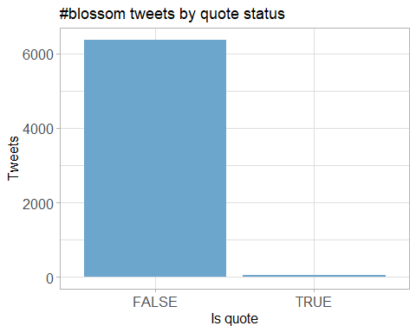

## Quote count

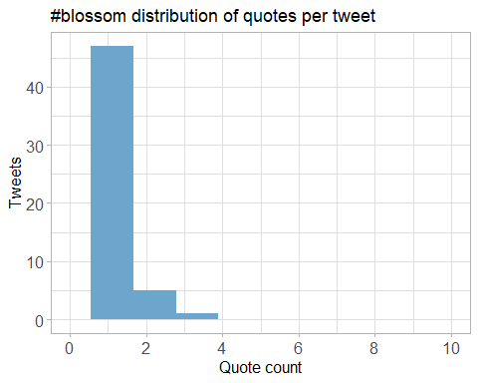

## Top quotes

Joining, by = “quoted_status_id”

|  |  |  |
| --- | --- | --- |
| screen_name | text | quote_count |
| wearealtervego | Taking in the #nature around us…#andbreathe #blossomwatch #savethebees #savetheworld <https://t.co/9OKBi1ot9E> | 3 |
| GillianFoxcroft | Wonderful initiative by @nationaltrust Lucky enough to live near @KedlestonNT where this blackthorn was heralding spring, but blossom is accessible in our towns and cities too #BlossomWatch <https://t.co/l3nMn9dvGe> <https://t.co/Nri4nxd3vL> | 3 |
| MedialabGroup | For what is probably the most anticipated spring in decades, we are incredibly proud to have supported our partner @nationaltrust in launching their latest Blossom campaign. The National Trust Blossom campaign runs across TV, national press and digital. #BlossomWatch <https://t.co/wMan1xCxRM> | 3 |
| weather2travel | Will you be joining @nationaltrust #BlossomWatch? <U+0001F338><U+0001F440> #thursdaymorning #ThoughtForTheDay #spring #bliss <https://t.co/aiQYIY1n5N> | 2 |
| HeiniHeikkil | Mesmerising, refreshing blossom shared by millions in social media <U+0001F338>#UKhanami #BlossomWatch <https://t.co/Ut9p5H0aEL> | 2 |
| NaturalEngland | Our research shows that nature is more important than ever to us since the pandemic started. We’re taking more notice of small changes in nature and signs of spring, like beautiful apple blossom. Share your pictures of blossom with @NationalTrust using <U+0001F338>#BlossomWatch <U+0001F338> <https://t.co/KlDTIYa46E> | 2 |
| radiowinch | Spring is on the way. Celebrate the arrival of blossom near you with #BlossomWatch share your photos <https://t.co/B0TuHmf6Sk> | 2 |
| LauraSkitt_ | I love blossom trees so much. It reminds me spring is nearly here which means my birthday is nearly here (end of April, but still!) #BlossomWatch <U+0001F338> <https://t.co/gB9yiEInEo> | 2 |
| sheffieldparkNT | Here at @Nationaltrust we are celebrating the delicate clusters of flowers that are starting to appear on the trees- #blossomwatch is here! Have you spotted any blooms festooning the trees? Share your pics on our blossom map with #BlossomWatch <https://t.co/Uk6EYfJsV4> <https://t.co/T1QMKLUHwo> | 2 |
| DerbyUniPress | Research @DerbyUni is making important contributions to initiatives designed to enhance our #wellbeing and strengthen our relationship with #nature, such as @nationaltrust #BlossomWatch, which has been launched today. @findingnature <https://t.co/c4ZAhGJs1Q> | 2 |
| MiriamDobson | Great blog & paper! #BlossomWatch is such a fantastic opportunity to engage with moments in nature - these simple moments of noticing are so important for wellbeing (as this research demonstrates!) <https://t.co/pBwUoaQ3ZS> | 2 |
| AdamDyster | Really excited to have kicked this off today - and looking forward to seeing MPs’ #BlossomWatch pictures from all over the country <U+0001F338> We definitely need a dose of hope & beauty right now- and nature’s providing that on our doorstep! <https://t.co/y2GsraWems> | 2 |
| heritage_lizzie | Itâ€™s time for #BlossomWatch @nationaltrust <U+0001F333> <https://t.co/PnZ35hHU4R> | 2 |

# Media

## Media count

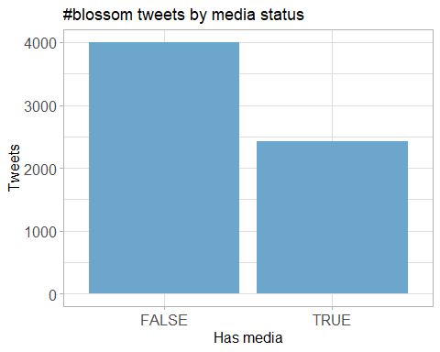

## Top media

|  |  |  |
| --- | --- | --- |
| screen_name | text | favorite_count |
| nationaltrust | Pause to soak up the sweet scents and soft songs emanating from blossom branches. These colourful trees are a feast for the senses. #BlossomWatch <https://t.co/GsXfF5KPAE> | 1104 |
| DrDarrenRFlower | Central Park New York #spring #spring2021 #blossom #cherry <https://t.co/Oimq2hRU1k> | 762 |
| nationaltrust | If you’re lucky enough to spot a hare hopping around, the feeling of elation will stick with you all day. #EveryoneNeedsNature <https://t.co/Vpo5aADU9Q> | 697 |
| nationaltrust | Everywhere these delicate flowers emerge, they bring delight with them. Thanks to everyone who’s helped spread the joys of blossom so far - keep the photos coming with #BlossomWatch. Photos: Joanna A, Catherine A, Shonali B, Cara W. <https://t.co/6znNDEdvKC> | 691 |
| nationaltrust | <U+0001F338>#BlossomWatch<U+0001F338> Lockdowns have changed the nation’s relationship with nature for the better. We are feeling more connected thanks to our daily strolls and taking more notice of the changing seasons. <https://t.co/JtIkqgUorV> | 562 |
| nationaltrust | Spring is on the way. Celebrate the arrival of blossom near you with #BlossomWatch: <https://t.co/TaQxr1YkU8> <https://t.co/kQ93UDZlCP> | 499 |
| nationaltrust | Happily dancing in the breeze, a golden daffodil is full of cheer. #EveryoneNeedsNature <https://t.co/hSOWdCCnPL> | 484 |
| MikeDoylePhotos | Early autumn at Sheffield Park, East Sussex. #Sussex #England #NationalTrust #landscape #landscapephotography #travel #travelphotography #photo #photography #photooftheday #NaturePhotography <https://t.co/fqSC6f0xMQ> | 465 |
| MikeDoylePhotos | Spring colour at Sheffield Park, East Sussex. #Sussex #England #NationalTrust #landscape #landscapephotography #travel #travelphotography #photo #photography #photooftheday #NaturePhotography <https://t.co/uFdcfnor39> | 431 |
| nationaltrust | Nature’s alarm clock is getting louder with each new day as the birds look to find their spring mates. Which birds are waking you up in the morning? Photos: Jenni B, @NTCastleWard #EveryoneNeedsNature <https://t.co/qFLlRf3gL7> | 416 |
| nationaltrust | One of life’s simple pleasures that can be enjoyed from anywhere. Engross yourself in the calming colours of a sunrise. #EveryoneNeedsNature <https://t.co/l5xkDICUPn> | 407 |
| MikeDoylePhotos | A view of the Middle Lake at Sheffield Park, East Sussex. #Sussex #England #NationalTrust #landscape #landscapephotography #travel #travelphotography #photo #photography #photooftheday #NaturePhotography <https://t.co/HAeeTUTOI4> | 394 |
| nationaltrust | As the days lengthen, take an early evening walk and listen out for the blackbird chorus. Perched as high as they can, they fill the spring air with song. #EveryoneNeedsNature <https://t.co/fokl4eudbL> | 376 |
| nationaltrust | A bright burst of yellow Forsythia is like the sunshine after the rain. Flowering with the spring bulbs, these blooms are a sure sign of the gardens we care for reawakening after winter. #EveryoneNeedsNature <https://t.co/eRc7pCw2nJ> | 361 |
| nationaltrust | This spring, spend time under the delicate blooms of a blossom tree and watch as nature’s confetti dances to the ground. Share your pictures of pink, white and green with us using #BlossomWatch<U+0001F338> <https://t.co/0WFkQ61nfD> | 317 |
| MikeDoylePhotos | Some more spring colour at Sheffield Park, East Sussex. #Sussex #England #NationalTrust #landscape #landscapephotography #travel #travelphotography #photo #photography #photooftheday #NaturePhotography <https://t.co/N5aG6i4wW5> | 311 |
| MikeDoylePhotos | A summertime view of the house at Sheffield Park, East Sussex. #Sussex #England #NationalTrust #landscape #landscapephotography #travel #travelphotography #photo #photography #photooftheday #NaturePhotography #architecturephotography <https://t.co/RKDuxeqWpw> | 288 |
| nationaltrust | <U+0001F338> With buds beginning to burst weâ€™re asking you to help us track the blossom as it appears. Just add #BlossomWatch to your tweets, with location settings on, to add your sightings to our map: <https://t.co/Oto3d8C9ZQ> <https://t.co/9a3Q2umF03> | 239 |
| MikeDoylePhotos | Autumnal view at Sheffield Park, East Sussex. #Sussex #England #NationalTrust #landscape #landscapephotography #travel #travelphotography #photo #photography #photooftheday #NaturePhotography <https://t.co/FqII3JWs8w> | 237 |
| nationaltrust | When you feel the warmth of the spring sun, keep an eye out for the fluttering of pale wings. Brimstone butterflies are a welcome sign of the changing season. #EveryoneNeedsNature <https://t.co/MCfhLeds7k> | 215 |

### Most liked media image

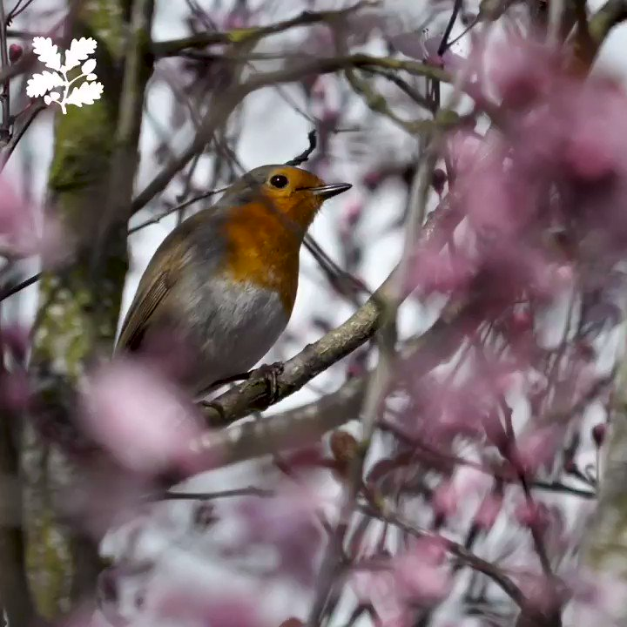

# Tweet text

The 100 words used 3 or more times.

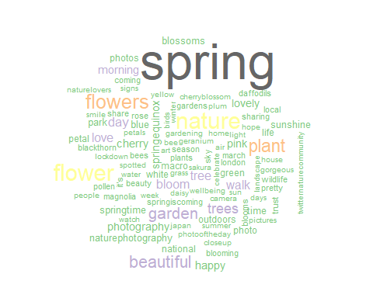

## Tweets by Tweet Length

